April News

I am pleased to say I have not heard of any bereavements this month. Glenis Sanders from Groby Lane very bravely made the decision to be baptised at the 11 a.m. Communion Service on Sunday, March 15th. She was supported by a large number of family and friends and is seen here with husband Glyn holding the lighted candle she was given by Anne Stratton the Stipendiary Curate who took her first Communion Service. The Baptism was conducted by the Rev. Simon Foster Rector of Anstey and Thurcaston with Cropston.

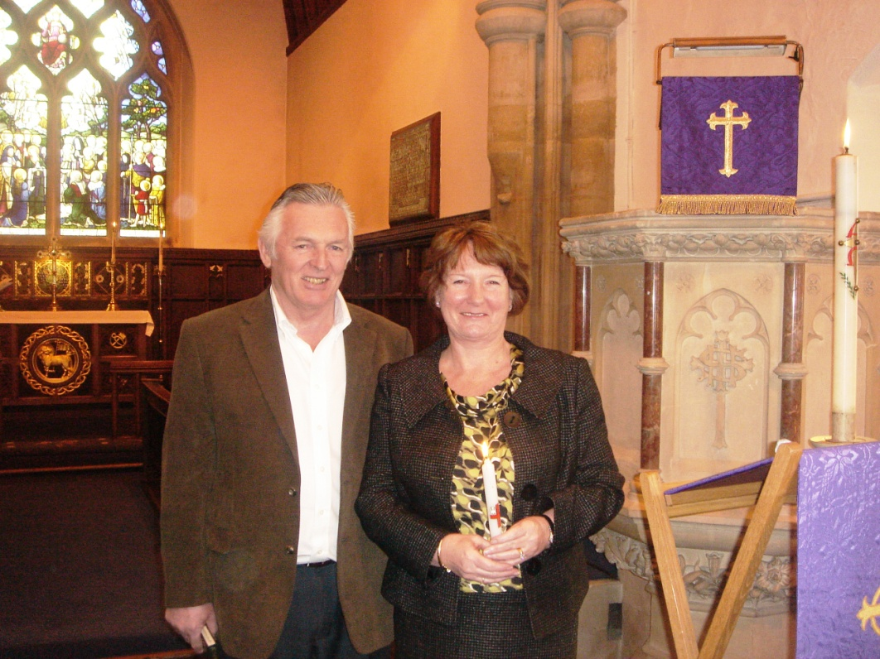

Pam McMorran

News Editor